**Board Game CA - Design Document**

**“NORMANITY”**

**Ben Watt, Keelan Murphy, & Oisin Murphy**

1. **Background or Story Outline**

The story of our board game is centered around the Norman invasion in Ireland ~(1167–1185), particularly how their settlements were set up. Historically, Norman settlements often started as motte and bailey castles; small wooden settlements that achieved a rather small space for Normans to live in. Over time these settlements expanded, taking over land to expand their resource pool. As a result, the Normans were able to build stronger defenses, monasteries & various other structures. This process of settlement development is the premise of our game, the players will work through a gamified version of this process.

The story of this game is somewhat fictional in nature, but uses historical figures and contexts as supplements. The story revolves around 4 founders of Norman towns, who have in this instance, started their towns at the same time. Each player will play as one of these founders (up to 4), and will race to advance their territories so that they might have a chance of reclaiming the throne of Diarmait Mac Murchada. The arc of this story that is played within the game is one of preparation. The players must, as the founders, build their own strongholds to prepare for the imminent fight for the throne, the fastest to do so receives Diarmait’s favour.

**The founders from which the players will choose are:**

* William Marshall & Isabella de Clare (NEW ROSS) - Blue
* Hugh de Lacy (TRIM) - Orange
* John de Gray (ATHLONE) - Purple
* Mayer de Bermingham (ATHENRY) - Green

1. **Educational Aims & Objectives  
   (i) - Critical Outcomes (main learning outcomes)**

The critical outcomes that we intend to achieve are as follows:

* Players will learn more about Norman towns in Ireland - their founders, how they began, and somewhat how they developed.
* Players will learn the reason that Normans were called to Ireland - that being to reclaim the throne of Diarmait Mac Murchada.
* Younger players will learn how to be resourceful with what they have and will gain an understanding of why the Normans needed to be resourceful.

**(ii) - Incidental Outcomes (supplementary learning outcomes)**

As a result of playing the game, it is possible that a player could do any of the following to learn more about the setting / context of the game.

* Research via the internet, books, or museums to learn more about the Normans in Ireland - how they got here, why they came, under whose command did they arrive, etc.
* They could investigate the real life founders of the towns featured in this game. They could learn their life’s achievements, how these founders created these towns, and what trials & tribulations did they have to go through to get to that position.

1. **Description of Learners**

The learners intended to benefit from this game would undoubtedly be teenagers, approximately from the ages of 13 - 18. The reason for this is due to the game mechanics, and the fact that it is not necessarily the simplest of concepts. It would be somewhat difficult to comprehend for very young audiences, although that does not apply for all people. Those with an interest in strategizing and negotiation with other team members will hopefully find the territory expansion, material accumulation, and planning aspects of gameplay interesting.

These learners will hopefully gain some historical knowledge away from playing this game, maybe not from the story itself, but from the characters they play as, the processes they have to go through to improve their territory and the buildings they can create. The majority of learning outcomes will more than likely be supplementary, for example a player will learn from the game that the founders are responsible for starting the featured Norman town that still exist in Ireland today, but they may not learn why or how these people lived here, what caused them to settle in these areas, etc. It is open in regards to how much a player engages with the game, and whether they have the intuition to investigate for themselves.

1. **Topic Motivation**

When deciding what part of Irish history do use for our board game, we wanted something that would not be the first thing to come to mind, something that not many people knew about. Creating a board game about the 1916 Rising and the Republican Irish Army would not only be __ but would also be controversial and will more than likely be unappealing to potential players from Northern Ireland and England. There is also the issue that many irish children may be reluctant to play as the English due to the events of the 1916 rising.

We didn’t want a game based on a battle either as with some children, this may lead to conflict and temper tantrums. We also wanted players to learn to work with what they have without taking from other players by force as this discourages fair play. We wanted a topic which could be progressive and not destructive.

After looking at some topics such as a family feud in Ulster and the famine we decided that The Norman Invasion would be most suited to what we wanted. It had the potential for the sense of achievement from progressive development that the famine lacked. It also lacked the sadism which may have derived from a game about the family feud and had potential for opposing players to trade. Choosing the topic of the family feud would not have allowed for trading as the opposing families despised each other.

1. **Playing Context**

Our board game can be played in any sort of environment with 2 to 4 players at a time. this can be at home, with the family, or maybe in college with some friends. It is rather approachable for new players and should not be intimidating, thus making this rather fun when in a group. Some of the reasons a newcomer may want to play is the fact that the board game is based on Irish history. This may pique the interest of some potential players. Other reasons may include the style and appearance of our board game or rather, the rules themselves that bring attention. Since the game begins with players rolling for their turns, the thought process in the player's head may be a hope for the highest roll, so that they may be able to potentially have advantage over their adversaries. This creates a competitive type attitude in our players. Planning out their strategy from start to finish and figuring out if certain choices will result in their victory or defeat are both by-products of this attitude, and are evidence of critical thinking and engagement with the game’s mechanics.

1. **Content:**

**(i)**

* Facts:

1. Each founder represents the people who started the towns included as part of the game. Each of them is responsible for building the castle at each town, the only difference being when they did this in reality (in the game they are all doing this at the same time).
2. The towns included in the game are all Norman towns that exist in Ireland, most of which did begin with Motte and Bailey Castles (the castle that each player starts with in game).
3. The Normans arrived in Ireland due to Diarmait Mac Murchada. He lost his throne as the King of Leinster and wanted the Normans to help him reclaim his throne.

* Concepts:

1. The players will gain points by doing specific tasks. For example taking over territory, upgrading their castle, and building other structures.
2. The game’s winner is decided using a points system. First to 10 points wins.

* Principles:

1. All territories start with a means to produce wool, stone, and barley.
2. The territories that you take over will only produce materials for their owner once their assigned number is rolled at the start of a turn.
3. A player can only take over territory adjacent to their own, owned territories.
4. Once a player owns a territory, an ownership counter is placed on it and it cannot be taken over by another player.
5. The Founder characters give no advantage / disadvantage to the player.
6. For every 3 territories you own, you gain 1 point.
7. You gain the “Largest Land” card once you own more territories than any other player in the game (only occurs after a 3 territory threshold). This gives you a bonus point. A player must surpass you in territory number to take that away from you.

* Processes:

1. To take over a piece of land, build structures, or improve their castle, the player must have the available resources as noted in the rules, and will spend those resources in doing so.
2. On any player’s turn, that play will gain 1 wool, 1 stone, and 1 barley from their home territory.
3. If the player owns the special counter in the center of the board, they receive +2 more of its material every turn.
4. If a player owns a blacksmith, that player gains 1 iron per turn as well as all the standard turn-by-turn materials.
5. At the start of each turn, the player rolls two D6. Any owned territories with a number equal to that which was rolled give their owner one of their resource.

**(ii)**

In regards to education elements, whilst playing this game, the players will learn about 4 Norman towns existing in Ireland and the people behind them. They will become familiar with the names of those who built castles so many years ago, and will understand somewhat why they came to Ireland in the first place - summoned by Diarmait Mac Murchada. During gameplay, the player will learn (in a very exaggerated way) how Norman settlements developed, and the types of buildings they housed - Castles, Blacksmith, Monastery, etc. They will see the progression from Motte and Bailey Castle through to a Stone castle with better defences. Many of these things are intended to be educational, but are rather shallow in the game’s context. In the case where a player investigates online as to who these people are / what these places are, they would be able to see more in-depth information on each topic.

Regarding entertainment elements, many historical aspects of the Normans in Ireland had to be compromised on. To create a game in which 4 real Norman towns race to develop we had to put together 4 towns that arose at different times in history into the same environment. This allowed us to create a fictional story premise that used historical figures and contexts, constrained within a comprehensive board that is designed to give each player fair access to the randomized hexagons. As well as bending time and history, we had to exaggerate greatly when it comes to territory expansion, territory upgrades, and resource gathering. The territories’ proximity to materials is very warped and purely for entertainment purposes. The fact that each game sees a new arrangement of hexagons each time completely disregards any historical accuracy, and is purely for the sake of variation and replayability, as well as giving no player any intended advantage.

1. **Player’s Aims & Objectives**

There are quite a few objectives to be found within this game. The overarching one being to reach 10 points and win the game. In order to achieve this however the player must develop short term goals. At the start of the game the player will want to take over territories to gain points and increase the chances that they would receive materials. They might wish to rush to the center of the board and take the special hex, giving them a major advantage. Over time they might wish to save their resources and upgrade their castle, build a monastery, or build a blacksmith. All of which contributes to their point count. They may wish to trade with other players for mutual benefit, or to catch another player out for their own advantage.

1. **Walk-through of the game from the Players’ perspective**

The game begins with setting up the board. To set up the board the player will need the following components (all but dice included as part of the game):

* Territory hexagons (28)
* Special hexagons (4)
* Number counters (28 - < 3 x 2, 3 x 3 , 2 x 4, 3 x 5, 2 x 6, 2 x 7, 1 x 8, 3 x 9, 3 x 10,

3 x 11, 3 x 12 > )

* Ownership counters (Green, Orange, Purple, Blue <10 of each>)
* PHASE 1 Castle upgrade counters (4)
* PHASE 2 Castle upgrade counters (4)
* Starting pieces (4)
* Game border (4)
* Blacksmith counters (4)
* Monastery counters (4)
* D6 (2)
* D4 (1)

The board will be set up by first arranging the game border into a square shape, then placing the starting pieces in each corner of the now assembles border. Once this was done, the player will shuffle all territory hexagons and place them one-by-one into the area, moving inwards in a clockwise form. The player will leave a gap in the center for a special hex to be placed. To decide the special hex for any particular game, the player must roll a D4. The result of which will dictate which special hex will be placed in the center for the game.

After this, the player will have to shuffle the Number counters and place them on each hexagon (excluding the center) in the same fashion. Each player will then choose the Founder they wish to be and receive the associated coloured Ownership counters.

Next, the player will roll 2D6, and document what result they get. Once every other player has done the same, if the player has the highest number they go first. The subsequent players take their turns in clockwise order.

The player will need paper to document the number of materials they own at any time, adding 1 Barley, 1 Wool, and 1 Stone to their inventory on every one of their turns. The player on their first turn can spend these materials to take over their first territory, after which the price of each territory goes up. The player will have to roll a dice at the start of their turn to activate territories with the same number, if the player owns a territory with the same number, they gain 1 of that territory’s resource.

The player will, over the course of the game, take over territories and gain resources, with the main goal being to gain 10 points to win. To do this, the player must upgrade their castle, as well as build structures such as the Monastery and the Blacksmith, all of which give varying amounts of points.

1. **Evaluation: An analysis of where your game succeeded and failed.**

When gameplay begins, the pace starts of quite slow and takes a while to speed up to an adequate pace which entertains the players. One aspect of the game which slows down gameplay is the number of requirements to upgrade the castles, build monuments, and expand territories. We expect that reducing the number of these requirements will make gameplay more fluid and enjoyable for all players.

The point points system may need to be changed. Perhaps reducing the amount of points gained from owning the Most Land Card as this may give the winning player an unfair advantage and discourage the losing players. The Most Land Card may however be useful without giving bonus points as having it represents the character's reputation in that scenario and thus provides incentive for other players to attempt to take over the most land and gain that card.

Territories only produce resources for their owners once their numbers are rolled meaning that players can potentially go a number of rounds without gaining any resources from any territories which do not include the territories the players start off with. This can be frustrating to players.

Some numbers are more common to be rolled from two dice. For example, the number 8 is much more likely to be rolled than the number 2 because 8 can be rolled by many combinations. Players who own territories with numbers less likely to be rolled may also experience frustration and will have a disadvantage against players with territories likely to produce resources.

**(ii)**

**Successes and failures in our board game from an educational perspective.**

* Upon starting gameplay each player must choose which Norman they would like to play as. At this point they learn the names of these Normans and which castles they owned.
* The players learned about the stages the Norman castles took to their final stage.
* The game does not educate players about each Normans town founder in depth, but rather communicates their association with their respective town.

**Successes and failures of our board game from an entertainment perspective.**

* Players were drawn into game play due to the suspense of not knowing who will get to the special hexagon first.
* Unfortunately once one player reached the special hexagon, others began to lose motivation.
* Players enjoyed gaining new territory and were happy when they gained a territory with a number they did not yet have as it gave them a higher chance of receiving resources.
* Players who continued to gain hexagons with numbers they already had were not as happy because they had a lower chance of gaining from it.
* Trading was particularly interesting. The player that initiated a trade did so with the intent to trick the other player to give up resources they would have needed to upgrade their castle. This caused hilarity when that player learned afterwards of the trickery that had taken place.

1. **Game Rules**

* This game can only be played with between 2 - 4 players inclusive.
* When setting up the board, all hexagonal pieces & number counters must be shuffled to ensure a random formation every game when assembled into the game board.
* To choose the special hex at the start of the game, roll a D4 and place into the center of the board the piece corresponding with the rolled number.  
  **1** - Wool (Shears)  
  **2** - Barley (Cart)  
  **3** - Stone (Mine)  
  **4** - Iron (Blacksmith)
* The requirements for each upgrade / territory / structure are as follows:  
   **Territory (+1 point per 3 territories [excluding special hex])**  
   1st: 1 x Stone, 1 x Barley, 1 x Wool  
   All future territories: 2 x Stone, 3 x Barley, 1 x Wool  
   Special hexagon: 3 x Stone, 3 x Barley, 3 x Wool, 3 x Iron (+1 Point)  
    
   **Castle Upgrade** 1st: 5 x Barley, 5 x Stone, 4 x Iron, 2 x Wool (+1 Point)  
   2nd: 5 x Barley, 4 x Iron, 10 x Stone, 4 x Wool (+2 Points)  
    
   **Structures** Blacksmith: 4 x Stone, 5 x Iron, 2 x Barley (+2 Points)  
   Monastery: 5 x Barley, 10 x Stone, 4 x Iron, 4 x Wool (+2 Points)
* First player to 10 points wins the game.
* For every 3 territories owned, the player gains 1 point.
* Player with the most territories (over a threshold of 3) is given the “Largest land” card. This grants them +1 extra point. This can only be taken away by another player if they surpass the owner in territories owned.
* Players may trade with each other for materials. The limits of this is to be decided by the participating players, and said trade can only take place if both parties agree to the trade’s specifics.
* At the start of each turn, the active player must roll two D6 dice, the result of which will activate hexagons with a value equal to that roll. All owned pieces activated by this roll will give their owner +1 of that territory’s resource.
* Players may only gain territory adjacent to their Town or previously owned territories.

**APPENDICES**

**APPENDIX A: REFERENCES**

A number of game elements derived from concepts found in the game ***The Settlers of Catan***.

**Designed by:** Klaus Teuber - 1995

**Official Website:** <http://www.catan.com/>

**Interactive Introduction to Catan:** <http://www.catan.com/game/catan#prof-easy>   
**Wikipedia Page:** <https://en.wikipedia.org/wiki/Catan>

**APPENDIX B: TABLE**

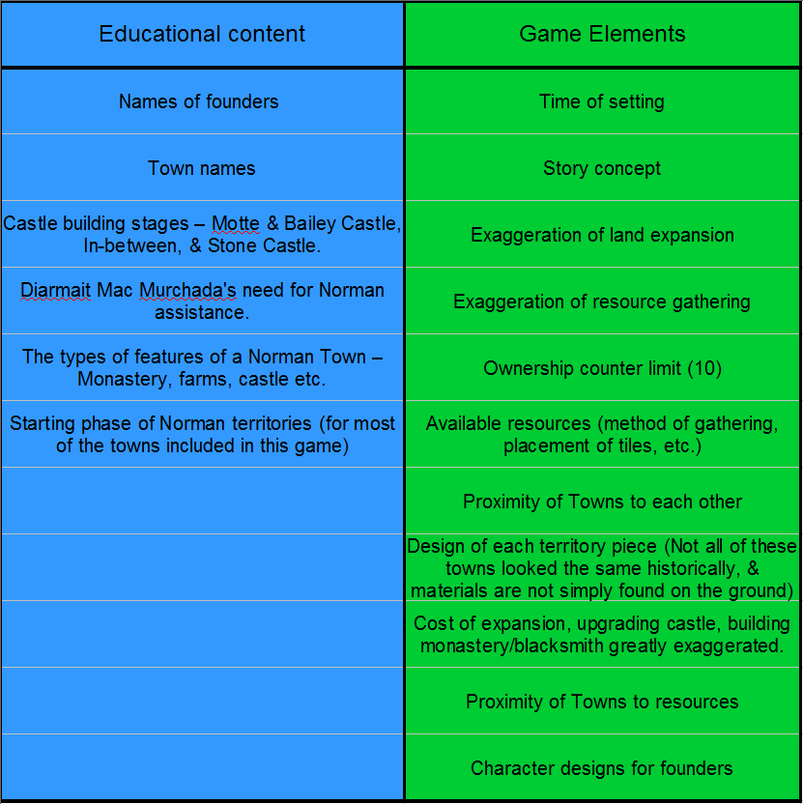

**APPENDIX C: PHOTOGRAPHS**

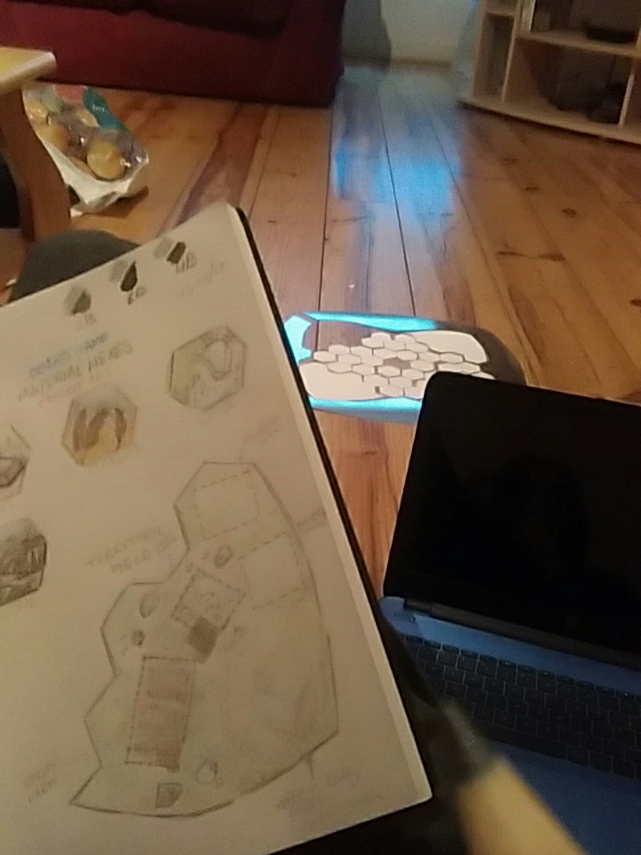

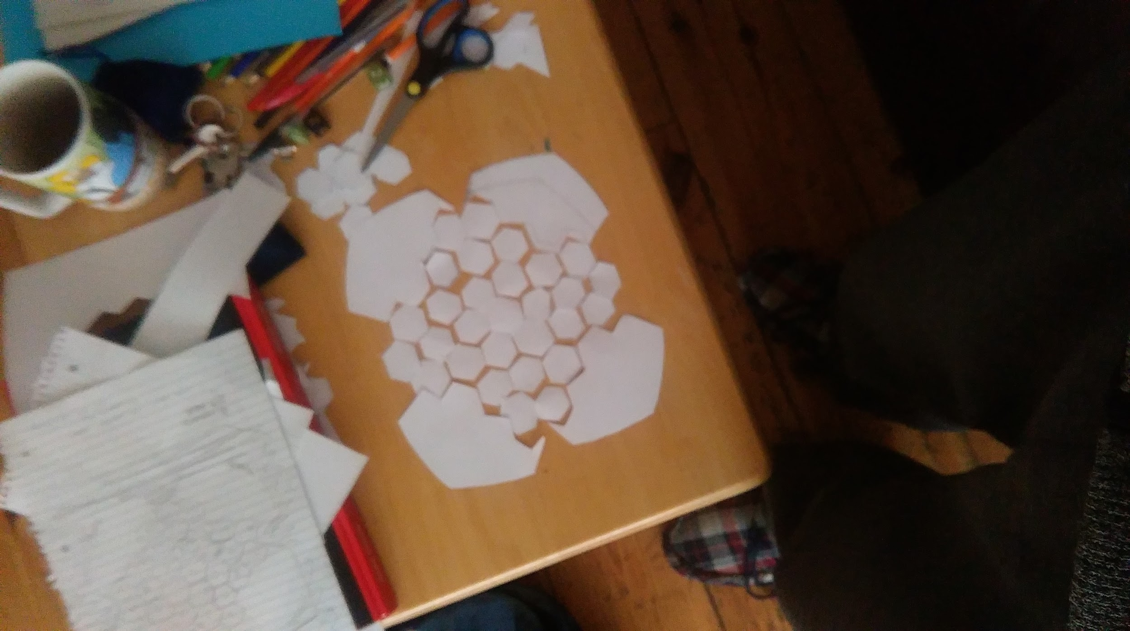

**APPENDIX D: SKETCHES**

